GOVERNMENT POLYTECHNIC AWASARI ( KH) PUNE



DEPARTMENT OF MECHANICAL ENGINEERING

A Project Report on

**“Multioperated Agriculture Equipment”**

Submitted in the partial fulfillment of the award of diploma of Maharashtra State board of Technical Education in Mechanical Engineering



**Submitted By**

MR.RAUT MAYUR SHIVAJI (17ME302)

MR.JAGTAP PRATIK VITTHALRAO (17ME303)

MR.WADEKAR RUTURAJ BALASAHEB (17ME304)

MR.MANE MAHESH RAJENDRA (17ME309)

**T.Y. (MECHANICAL)**

Under the guidance of

**Prof. ERANDE G.K. Sir**

2017-18

ACKNOWLEDGEMENT

We would like to take this opportunity to express our sincere gratitude to all those who have helped to work our project. Particularly we are grateful to our project guide **Prof. Erande G.K. Sir**, His proficient guidance throughout the process awakened thinking ability towards this project. His sincere attitude and friendly nature really inspired us.

We would like to specially thank all the non-teaching staff, especially in the workshop who helped us during the manufacturing and assembling part of the project.

We are also grateful to **Prof. UMALE Sir** Head of the Mechanical Department, for providing us required facilities in the collage for carrying out the project work & whose valuable support was a strong source of inspiration for us.

MR.RAUT MAYUR SHIVAJI (17ME302)

MR.JAGTAP PRATIK VITTHALRAO (17ME303)

MR.WADEKAR RUTURAJ BALASAHEB (17ME304)

MR.MANE MAHESH RAJENDRA (17ME309)

## ABSTRACT

As on today the whole world is facing a problem of energy crisis. If we want to continue for prolonged use of energy then we must try to save it as much as we can whether it is on large scale or small scale. Today we use various spraying technologies involving use of electrical energy, chemical energy of fuels. This fact makes us know that how large content of energy is getting used at such a places where mechanical energy can be used instead of direct energy sources.

This is a reason why we have implemented mechanical sprayer getting powered by human effort. Although these are serving the purpose, their range of working is not enough. They take considerably larger time for spraying. Thus what we have aimed is to design such a technology which will run on mechanical power but requiring less time for spraying than those which are hand operated. Thus considering today’s demand, we have come up with mechanically operated spray pump which is purely mechanical.

This device is having the advantage of taking less time for spraying once it starts. If we want to decrease the time further we just need to increase size of our piston and no. of nozzles with relative change in effort. In addition to all this we are implementing soil coulter along with spray pump so we can have double advantage.

Mechanical energy can be used instead of direct energy sources. This is a reason why we have implemented some mechanical sprayers getting powered by human effort. Although these are serving the purpose, their range of working is not enough. They take considerably larger time for spraying. Thus what we have aimed is to design such a technology which will run on mechanical power but requiring less time for spraying than those which are hand operated. Thus considering today’s demand, we have come up with mechanically operated multipurpose spray pump. As it has huge advantages so this concept should be used in agriculture.

### **Introduction**

India is land of agriculture which compromises small, marginal, medium and rich farmers. Small scale farmers are very interested in backpack type sprayer because of its price, versatility, cost and design. But this sprayer has certain limitations like it cannot maintain required pressure; it leads to problems of back pain. However this equipment can also leads to misapplication of chemicals and ineffective control of target paste which leads to loss of pesticides due to dribbling or drift during application. This phenomenon not only adds to cost of production but also cause environmental pollution and natural imbalance in echo system. The manually operated spray pump which will perform maximum rate in minimum time. Constant flow valves can be applied at nozzle to have uniform nozzle pressure. In the modern agriculture, the usage of pesticides is still increasing; moreover the 90% of these pesticides are being applied in the form of liquid spray and mostly by using the pressure gained from direct energy sources like electrical energy, chemical energy.

Increasing public concern about the potential damage of chemical and electrical inputs in agricultural spraying systems has challenged industry to develop new and effective methods of spraying which will maintain environment friendly approach. Agriculture plays a vital role in Indian economy. Around 65% of population in the state is depending on agriculture. Although its contribution to GDP is now around one sixth, it provides 56% of Indian work force . The share of marginal and small farmer is around 81% and land operated is 44 % in 1960-61. As far as Indian scenario is concerned, more than 75 per cent farmers are belonging to small and marginal land carrying and cotton is alone which provide about 80 % employment to Indian workforce. So any improvement in the productivity related task help to increase Indian farmer’s status and economy.

## PROJECT CONCEPT

* To overcome the disadvantages related with previous model, we have designed a model running without any fuel and also easy to operate for a user.
* Pesticide application plays an important role in pest management. Proper technique of application of pesticide and the equipment used for applying pesticide are vital to the success of pest control operations.
* The application of pesticide is not merely the operation of sprayer or duster. It has to be coupled with a thorough knowledge of the pest problem.
* All pesticides are poisonous substances and they can cause harm to all living things.
* Therefore their use must be very judicious. The application techniques ideally should be target oriented so that safety to the non-targets and the Environment is ensured. • Therefore, proper selection of application equipment is necessary.
* The requirement of coverage and spray droplet size depends upon the mobility and size of the pest.
* The mode of action of pesticide, its relative toxicity and other physicochemical properties, help to decide the handling precautions, agitation requirement etc. Further the complete knowledge of the equipment is necessary to develop desired skill of operation, to select and to estimate the number and type of equipment’s needed to treat the crop in minimum time and to optimize use of the equipment

.

## BACKGROUND:-

* The Indian farmers are (small, marginal, semi medium) are currently using lever operated backpack type sprayer consists of tank 10 to 20 liters capacity carried by two adjustable straps.
* Constant pumping is required to operate this which results in muscular disorder.
* Also this backpack sprayer cannot maintain pressure results in drifts or dribbling.
* Developing adequate pressure is laborious and time consuming. Pumping to perform operation is also time consuming.
* Moreover, very small area is covered while spraying .so; more time is required to spray the entire land.
* Back pain problems may arise during middle age due to carrying 10-20 liter tank on back.
* Cotton is one of the most important commercial crops grown in India. Over 4 million farmers in India grow cotton as their main source as income.
* For cotton about 5 to 6times spraying of pesticides is done. Cost of bullock driven is about 50000 now a day’s which is expensive for small crop area

## OBJECTIVE

* The suggested model can remove the problems of back pain, since there is no need to carry the tank (pesticides tank) on the back.
* We can add more number of nozzles which will cover maximum area in minimum time and at maximum rate.
* Work reliability under different working conditions.
* Decrease labor cost by advancing the spraying method.

## PRINCIPLE

* When the equipment is push by using handles, front wheel rotates and the gear is mounted on the axel of wheel is start to rotate and its rotation is then transferred to the pinion through the chain drive.
* The rotary motion of the pinion is converted into the reciprocating motion by the single slider crank mechanism due to this arrangement the connecting rod moves upward and downward which then reciprocate the piston of single acting reciprocating pump mounted at the top of storage tank.
* During the upward motion of connecting rod the pesticide drawn into the pump and during the downward motion of pesticides is forced to the delivery valve, the delivery is connected to pipe carrying the number of nozzles.
* Due to the motion of wheel the chain drive mechanism operate to reciprocate the piston inside the pump cylinder. But, this result in building up of pressure which seizes the movement of wheel.

## CONSTRUCTION AND WORKING OF SYSTEM

### CONSTRUCTION:-

* Manually operated spray pump has simple structure it consist of 3 wheels, piston pump, bearings, nozzle, shafts, trolley, pipe, crank shaft, freewheel, handle chain drive, etc.
* There is trolley like structure containing 1 wheels one at front.
* The rear wheels are connected by shaft. Bearings are provided at both sides for smooth motion. The front wheel is mounted at middle of the trolley.
* Freewheel is mounted on shaft connected to rear wheels. The free wheel is connected to crank shaft by chain drive. The crank shaft is then connected to piston pump with connecting rod.
* The piston pump is placed middle of frame which has reciprocating movement.
* The nozzle is mounted on upper side of the tank. Nozzle having flexible pipe which is move or turn any direction. We can also adjust the height of the flexible pipe. We use 2 nozzles in our sprayer.
* The whole assembly is connected to handle.

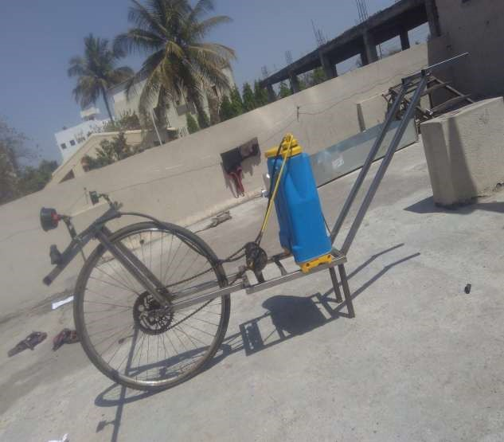

WORKING:-

* First bring the spray pump at field where you want to use then fill the pesticides or water as your need.
* Then connect the chain drive to freewheel
* When we start applying/running the machine remembers to adjust the nozzle direction and height as per requirement.
* By holding handle when we start pushing the spray pump the wheels start to revolve due to its motion.
* The sprocket/freewheel transfers its motion to crank by chain drives the chain drive is connected to sprocket and crank.
* The crank shaft provides its motion to piston pump it. The pump works vertically Reciprocating, through pipe the pesticides or water sprays on crop.

## ADAVANTAGES AND DIS-ADVANTAGES

### Advantages:-

* It does not require any kind of non-renewable energy is electrical and pressure energy.
* It reduces the fatigue of operator during the operation.
* It increases the efficiency of operator.
* It can cover more area of land during spray.
* It can adjust the height of spray by using adjustable.
* Its noise is less.

### Disadvantages:-

* In irregular area of land it can difficult to operate.
* In rainy days in muddy environment it is difficult to operate.
* For irregular crops this pump is useless.

**Applications:-**

* It major use in agriculture to spray fertilizer.
* In city and urban area it can use for spraying water on lawn, garden • It may be exercise device at morning during utilize in lawn.
* Use from spray chemical Pesticide in plants in farm.
* For the insecticides application to control insect pests on crops and in stores, houses, kitchen, poultry farms, barns, etc.
* For the fungicides and bactericides application to control the plant diseases.
* For the herbicides application, to kill the weeds.

.